**Submitted By Eric Miller 08/23/2014**

**Final Project Plan and Analysis**

**Intro:**

-The final project is another iteration of the fantasy combat program we have been making over this past term.

-This time the twist is that it will be a battle between 2 teams of characters, instead of just one on one.

-Each team will be comprised of a list (contained in a structure), the head of which goes into combat.

-The character in combat will return to the back of their team’s list should they win, but join a list of dead characters should they lose.

-At the end of the program, 1st, 2nd, and 3rd place characters are output along with their team.

-The ranking system appears to be up to us, so I will outline one below.

-More than one data structure type must be used.

**General Program Outline:**

1. I will build this based on assignment 4, the samurai combat game that I made. Characters, abilities, and combat rules will remain the same as before.
2. The first things that I need to add are data structures to allow for a tournament format. Of the data structures so far, I have found STL deque containers to be pretty versatile, and for a second container type I will use a STL stack container.
3. To keep track of wins and losses, I’ll add two new int member variables to the samurai class so that I can calculate a rank.
4. I will also have an int variable called ‘victory’ to mark a character as the winner of a fight. This variable is set to ‘0’ whenever a character returns to the back of their list.
5. Teams will be lined up in deque containers. The front members will be placed into a battle function based on the one I made in assignment 4.
6. The looser of the battle will have +1 added to their losses variable and their victory variable set to 0.
7. Likewise the winner will have +1 added to their wins, and their ‘victory’ variable set to one.
8. The character with a victory variable equal to one (the winner) will be sent to the back of their deque container. The other character (looser) will be added to a stack type container for dead characters.
9. Winners will have their strength restored.
10. An example of these structures in action can be seen below:

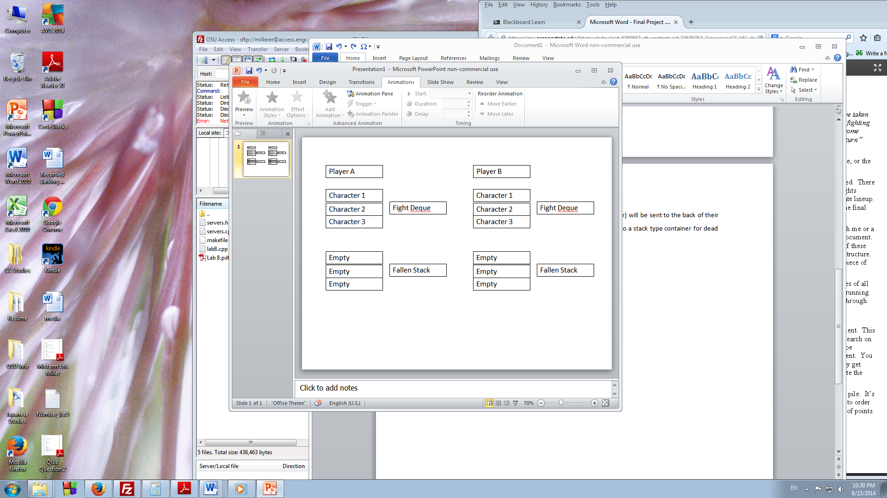

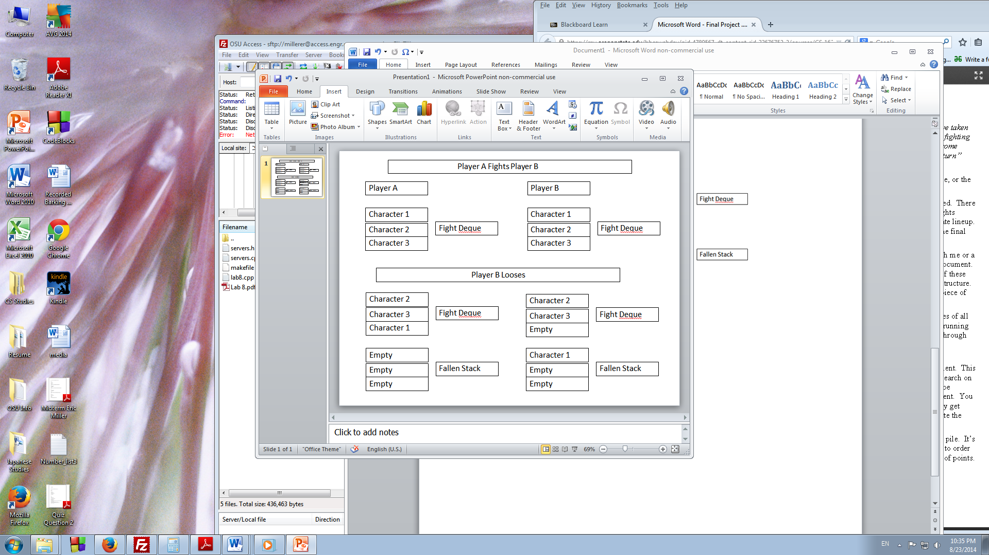

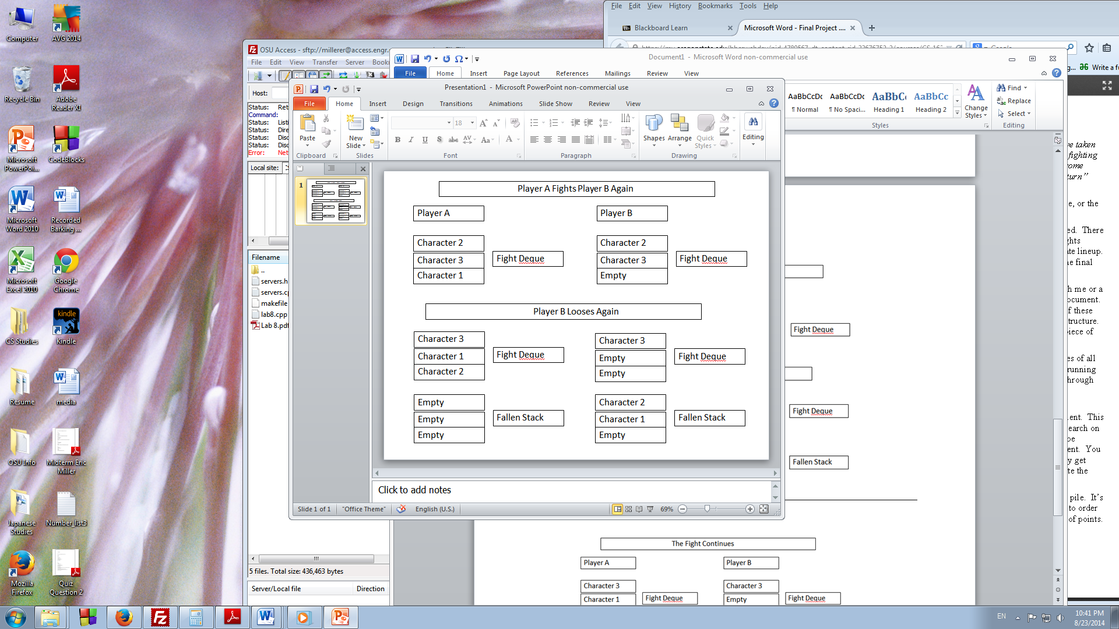

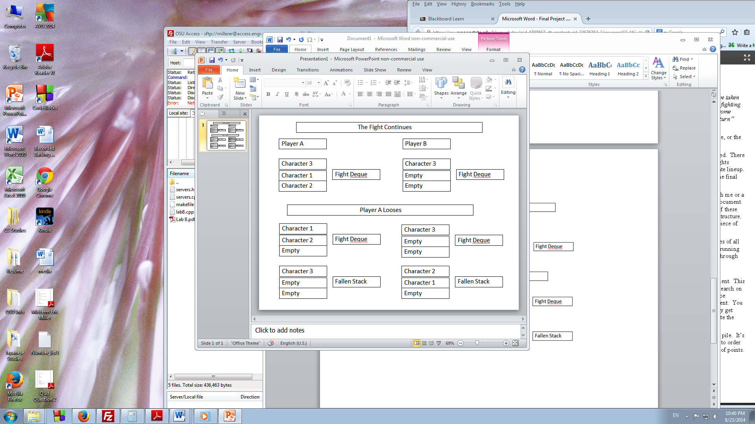

1. Hopefully this gives a good idea of what I am hoping to do with containers in this program.
2. I should note that all containers will be of type samurai character class.
3. Also keep in mind that for each loss or win the character’s win/loss count is changed.
4. The game finishes once a player’s Fight Deque becomes empty.
5. To calculate rankings, losses are subtracts from total wins. The result will be the ranking for the character.
6. I expect there to be ties, so in that case a winner will be randomly chosen (50/50 draw).
7. The top three characters by win will then be output, including which team they were on. The team with the most ranked character wins will be considered the overall winner.